**Exercise: Adding a measure**

**Introduction**

You have gained a good understanding of measures and how to create them using DAX and using the quick measure feature of Power BI.

In this exercise, you must apply your knowledge of measures by writing DAX expressions in Power BI for Adventure Works. You go through each step of creating a new measure calculation within your data model to enhance the reporting visualization and answer specific business questions.

By completing this exercise, you will demonstrate your ability to:

* Create a quick measure from the existing dataset within your data model.
* Create a measure by writing DAX expression.
* Format the measures for an appropriate data type.

**Scenario**

Adventure Works needs your help calculating its sales data using quick measures and DAX. Its main objective is to compute the running total for sales of its product line. This accumulated data will help the company analyze its sales trend based on various factors, like time, categories, salespersons, and resellers. It can then use these insights to make informed decisions.

Adventure Works provides a Power BI project file called *AdventureWorks.pbix*. that contains the required data model. You must load this dataset into Power BI, evaluate the data quality, and configure the model to ensure that Adventure Works can use it to make informed decisions.

[Adventure Works](https://d3c33hcgiwev3.cloudfront.net/i0P-DxIMSL-bXf-Cn45elQ_8dc5ecf898684280bbf3194008bdfdf1_Adventure-Works.pbix?Expires=1710028800&Signature=OOrLQfMENDWTqqyLDPd7E5x1YnyPQyeLMZzWv0mjV3UkU0y1Kva-cuYBxsJsrO3l2BOXyPrckQiZ58JknK17bYCFEluUL59BKrHtgO3zw3clcAkcAKtRmVn48~LXtjWhO355R0Ew6XXK5YfGA46RPez5jKYEKxHBTmmZiYuKNUI_&Key-Pair-Id=APKAJLTNE6QMUY6HBC5A" \t "_blank)

[PBIX File](https://d3c33hcgiwev3.cloudfront.net/i0P-DxIMSL-bXf-Cn45elQ_8dc5ecf898684280bbf3194008bdfdf1_Adventure-Works.pbix?Expires=1710028800&Signature=OOrLQfMENDWTqqyLDPd7E5x1YnyPQyeLMZzWv0mjV3UkU0y1Kva-cuYBxsJsrO3l2BOXyPrckQiZ58JknK17bYCFEluUL59BKrHtgO3zw3clcAkcAKtRmVn48~LXtjWhO355R0Ew6XXK5YfGA46RPez5jKYEKxHBTmmZiYuKNUI_&Key-Pair-Id=APKAJLTNE6QMUY6HBC5A" \t "_blank)

**Instructions**

Create a new Power BI project called *Exercise – Adding a measure*. Follow the steps below to complete the exercise.

**Step 1: Download the Adventure Works Power BI project.**

1. Download and save the Power BI project file **Adventure Works.pbix**. The file comprises a data model containing five data tables: **Salesperson**, **Region**, **Date**, **Products** and **Sales**.

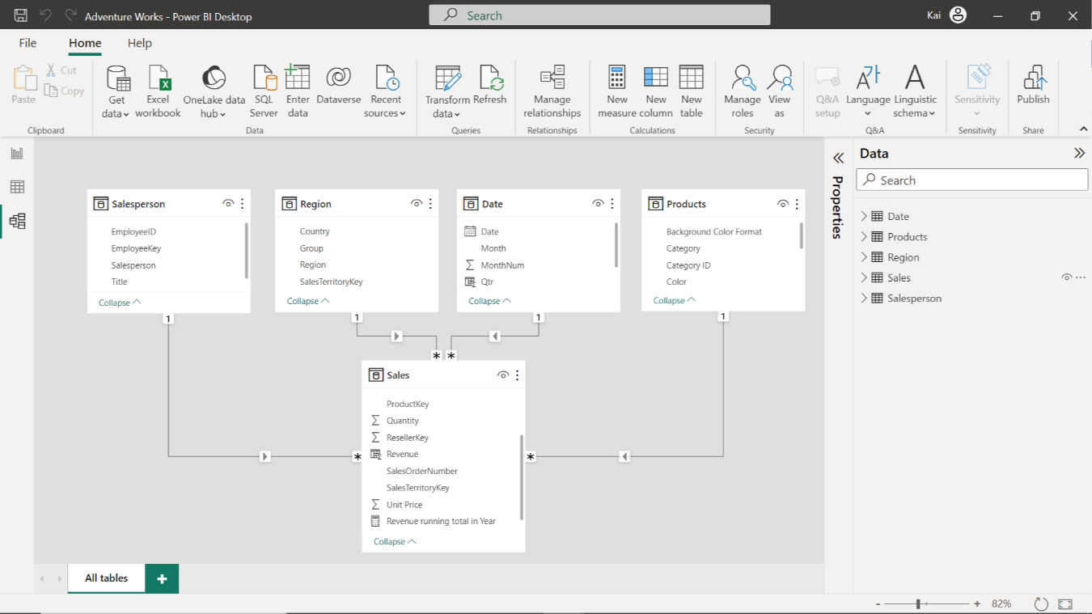

**Step 2: Create a Quick Measure.**

1. Once the data is loaded into the data model, create a new quick measure called **Running Total in Year** to calculate the running total of Adventure Work’s sales. You must create this measure using the **Total Sales** column from the **Sales** table and the **Year** column from the **Date** table.
2. Format the measure as **currency** data type within two decimal places.

**Tip:** You can create this measure by using Power BI’s **Quick Measure** feature.

**Step 3: Create a measure using a DAX query.**

1. Create an additional measure in the **Sales** table called **Total Revenue** using a DAX query. The measure must calculateAdventure Work’s total revenue by multiplying the **Quantity** of each product by its respective **Unit Price**.
2. Format the measure as **currency** data type within two decimal places.

**Tip:** You can create this measure using the **SUMX** DAX function in the formula bar of Power BI’s desktop interface.

**Step 4: Save the Power BI project.**

Save your Power BI project to your local computer.

**Tip:** Make sure you select an appropriate project name and folder path.

**Conclusion**

With these steps, you have successfully created two measures, one using the quick measure feature and the second by writing a DAX query. These measures will help you analyze Adventure Works data based on the analytical and business requirements.

Remember that when using DAX formulas, always ensure they are correctly formatted and that the column names match the actual column names in your data.

# **Exemplar: Adding a measure**

**Overview**

In the *Adding a Measure* exercise*,* you were asked to create new measures using Power BI’s quick measures feature and to write a DAX query within your data model to address specific analytical and visualization concerns.

Your tasks in this exercise were to:

* Download and connect to the required dataset.
* Ensure the correct relationships are set between the tables.
* Create two measures within your data model from the existing datasets.

This reading provides you with a step-by-step guide for completing these tasks. It also includes screenshots that you can compare against your work.

You can also review [*Creating quick measures*](https://www.coursera.org/learn/data-modeling-in-power-bi/lecture/xZZBs/creating-quick-measures)and [*Creating custom measures with DAX*](https://www.coursera.org/learn/data-modeling-in-power-bi/lecture/m25v9/creating-custom-measures-with-dax) videos.

**Step 1: Download and connect to the Adventure Works Dataset.**

1. Download and save the Power BI project **AdventureWorks.pbix** from the Coursera platform. The model contains five tables of data: **Salesperson**, **Region**, **Date**, **Products** and **Sales**.
2. The Power BI project is already configured to remove duplicate values. As the following diagram outlines, you must ensure the model relationships are appropriately set with cardinality and cross-filter direction.

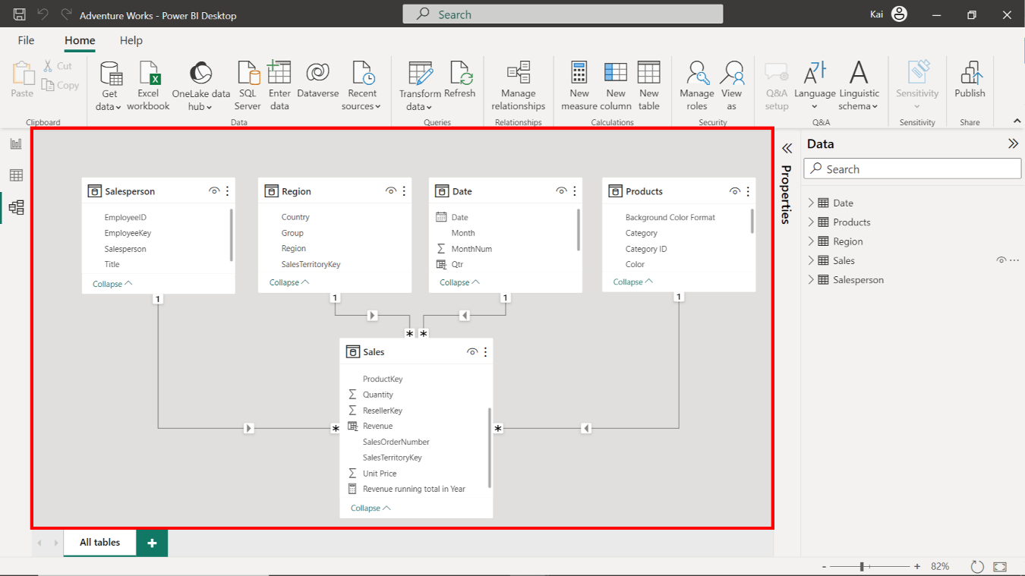

**Step 2: Create a Quick Measure.**

1. To create the **Running total in Year** quick measure, access the **Data view**, then **Calculations group**, and select **Quick measure** to open the **Quick measure window**.

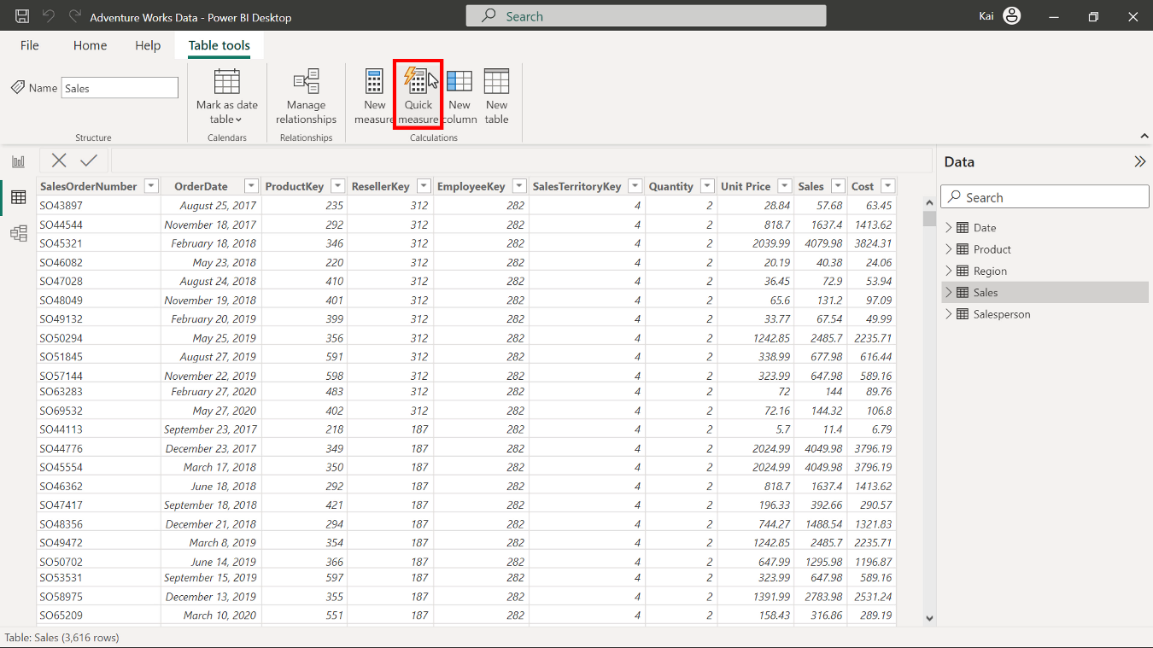

1. Under the **Calculations** dropdown menu, select **Running total** from the **Totals** calculation group.

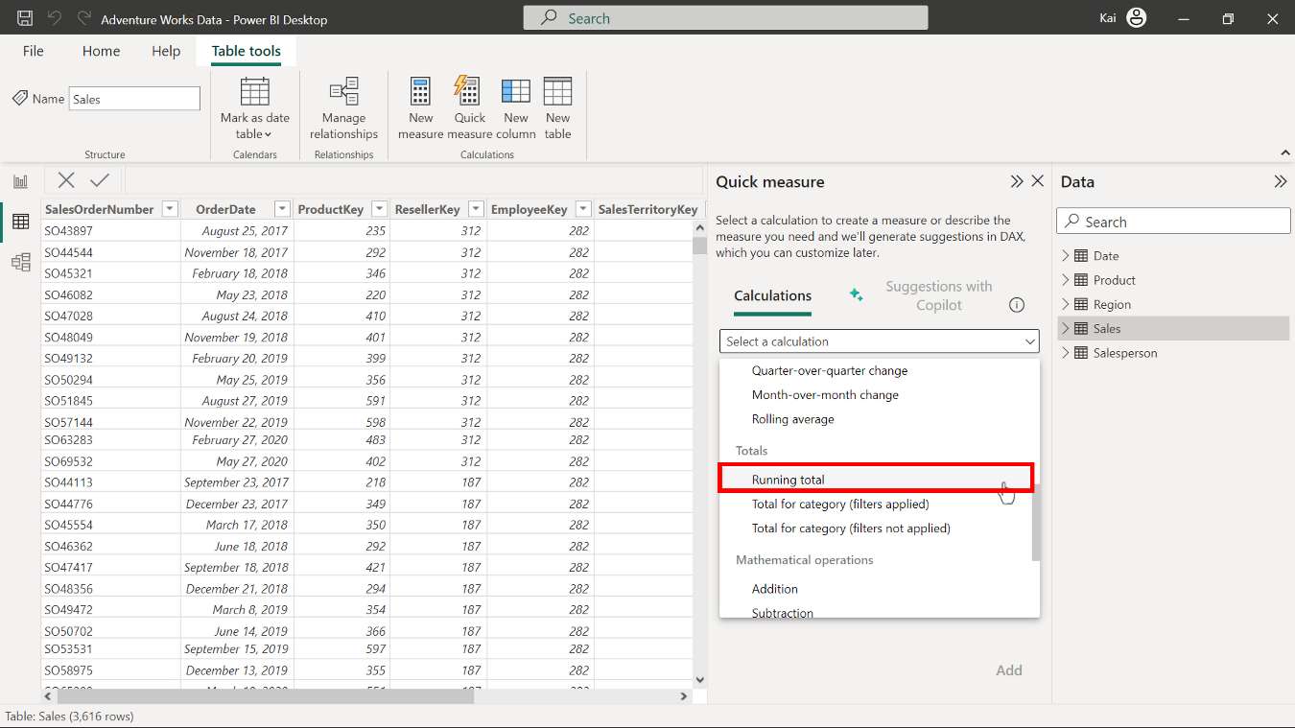

1. Drag the **Total Sales** column from the **Sales** table and drop it over the base value section. Drag the **Year** column from the **Date** table and drop over the **Field** section of the **Quick measure** dialog box. Retain the direction setting of **Ascending**.

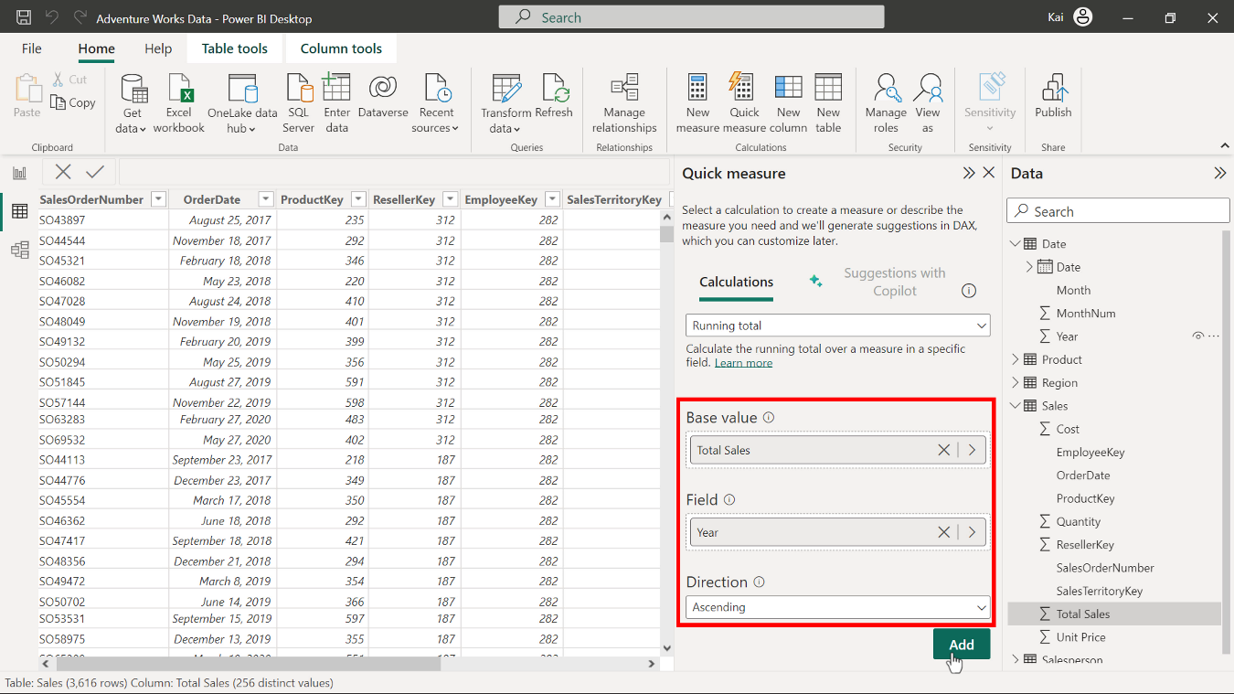

1. Select **Add** to complete the addition of your new quick measure. A new **Total Sales** measure appears in the **Data pane** under the **Sales** table.

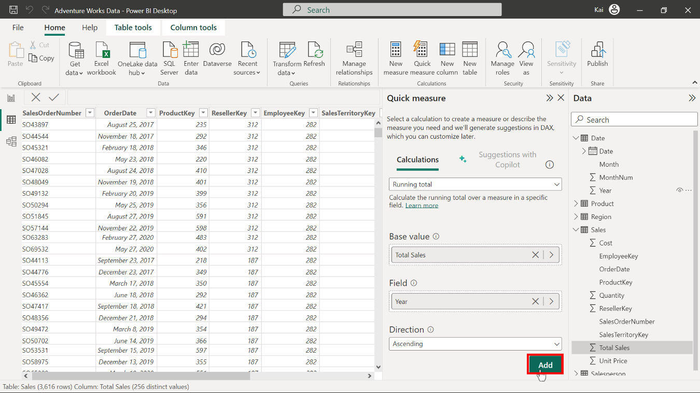

1. Power BI auto-generates the DAX code and names the measure as **Total Sales running total in Year**. Select the measure from the data pane, and in the formula bar, rename the measure as **Running total in Year**.

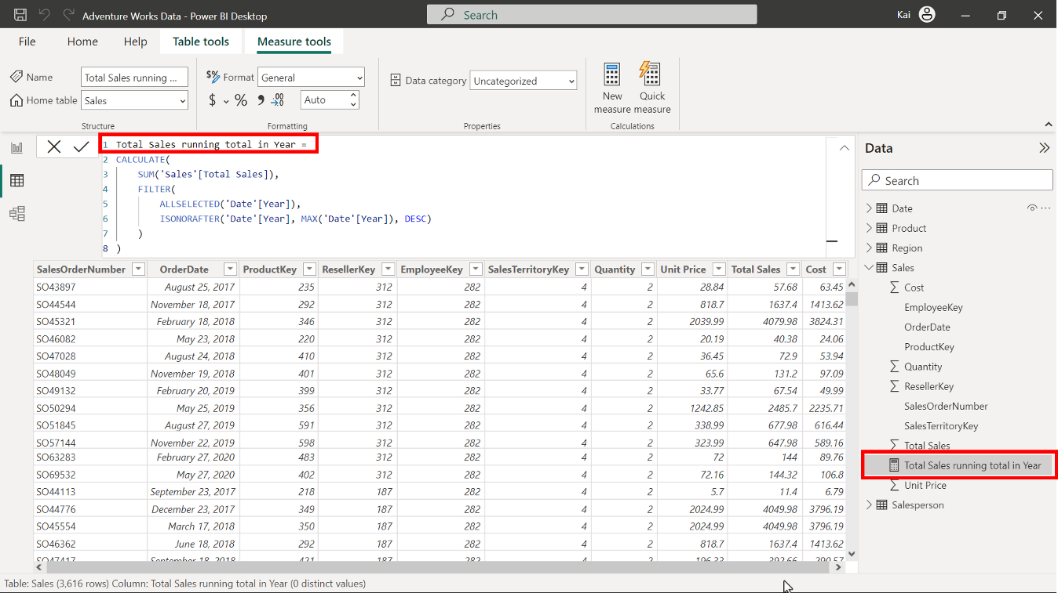

1. While selecting the measure, access the **Measure tools** tab and format the measure as **currency** with two decimal places.

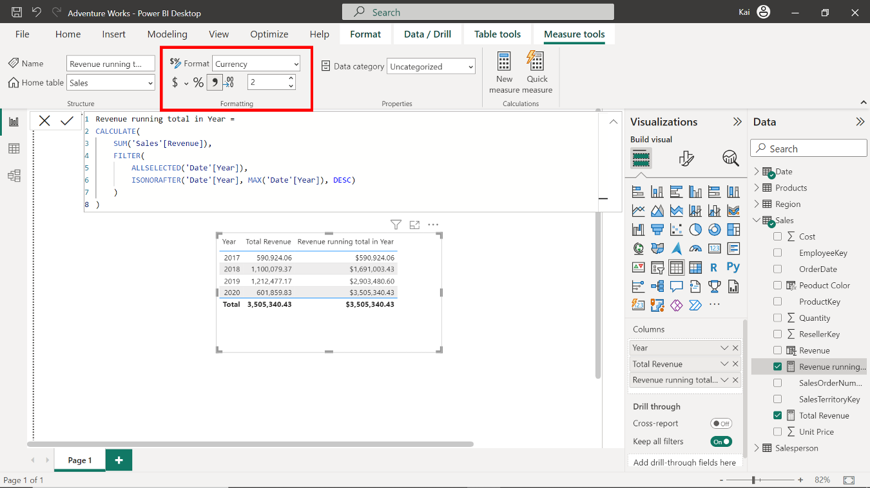

**Step 3: Create a measure using a DAX query.**

1. To create a new measure in the **Sales** table for **Total** revenue, select the **Sales** table from the **Data pane** on the right side of Power BI’s interface. Access the **calculations group** in the **data view** and select **New measure** to expand the formula bar. Copy and paste the following DAX code into the formula bar:

1

Total Revenue = SUMX ( Sales, Sales[Unit Price] \* Sales[Quantity] )

* **Sales** is the table name to be referenced.
* **Unit price** and **Quantity** in square brackets are the columns that must be multiplied to calculate the total revenue.
* The **SUMX** function iterates over each table row to calculate the total revenue.

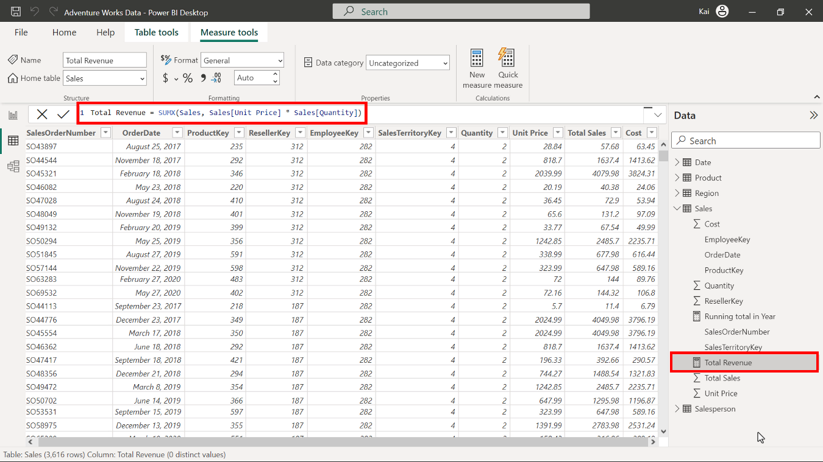

1. Select the newly created **Total Revenue**measure from the **Data pane** under the **Sales table**. Then access the **Measure tools** tab and format the measure as **currency** with two decimal places.

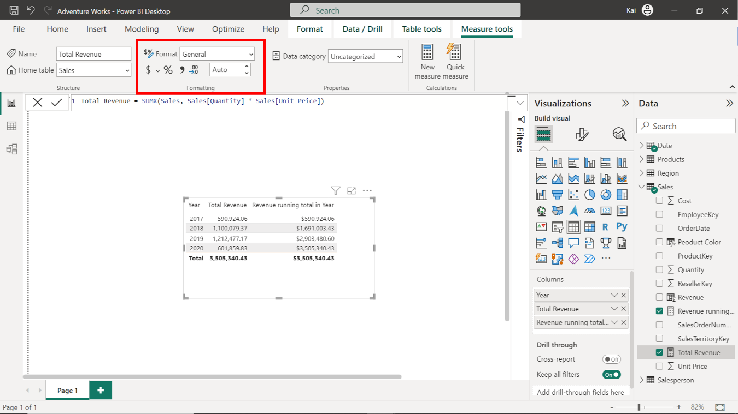

**Step 4: Save the Power BI project.**

To save the project, open the **File** menu, select **Save As,** and provide an appropriate name for the project along with a path to the folder on your computer.

**Conclusion**

With these steps, you have successfully created a quick measure in using Power BI desktop interface and one by writing DAX query. You can now analyze Adventure Works data based on the analytical and business requirements.

Remember that when using DAX formulas, you must always ensure they’re correctly formatted and that the column names match the actual column names in your data.